Memo to College Player: When the NCAA Drops the One Year Wait from the Transfer Portal, *Consider This Before You Apply*:

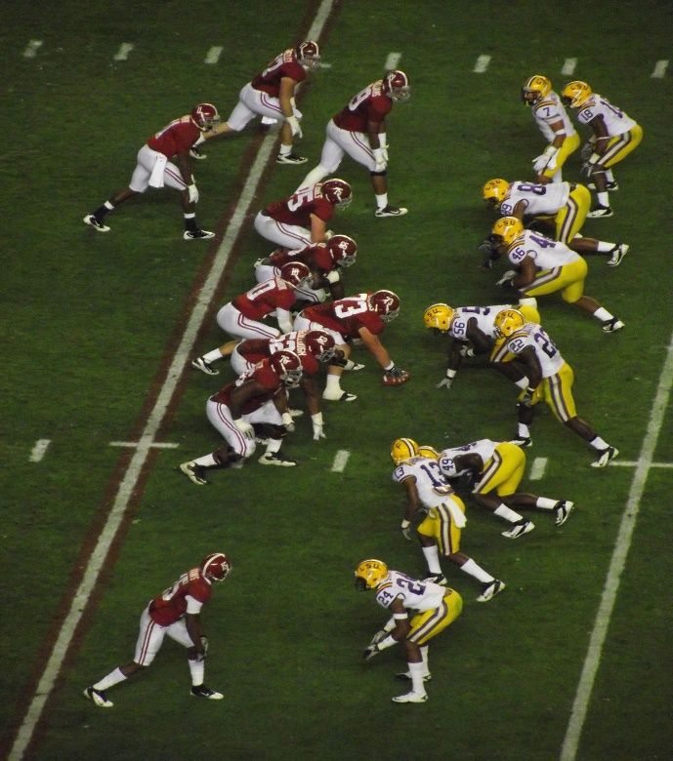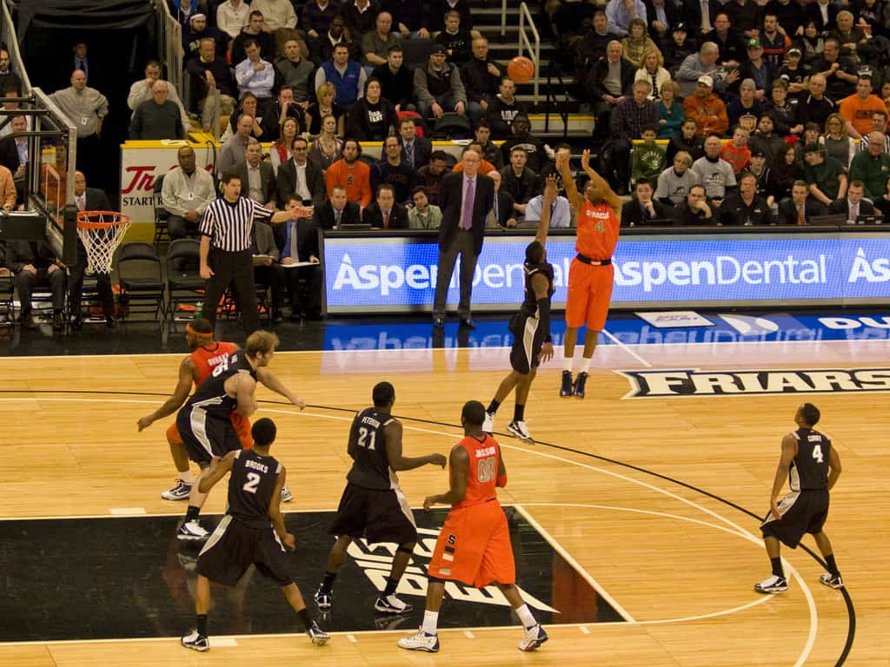

The NCAA is considering the elimination of the one-year wait penalty for D-1 scholarship athletes who place their name in the transfer portal. Smart money says it is just a matter of time. Currently, only those who receive a waiver can avoid sitting out a year. The liberalized rule would make a transfer all the more appealing to a player. Better upside of immediate playing time, and a year closer to a hoped-for pro career.

But before making that decision, or any decision that significantly impacts one’s life, there should be an analytical construct that guides the decision making. The process is the same whether your sport is football or basketball. There is an odd but apt analogy I’ll make to the stock market. A fundamental principle behind why we allow the general public to buy any publicly traded stock is that our system gives ordinary people access to important information about the stock they consider. The more informed they are, the better decisions they will make. The Securities and Exchange Commission oversees that process.

For college scholarship athletes, the SEC is called the NCAA. The principle is the same. You, player, have the opportunity to become well informed about the schools you may want to “buy” as part of your future in the sport. Like the stock market, the transfer portal is a medium of exchange. All schools know you are in the market, and they have a timeline to inform you of their interest. But you, player, have the greatest personal stake in this. The school will do just fine without you. So due diligence on your part is most important.

Consider the following:

1. Root Cause Analysis: As a general proposition, the best way to find a solution to a problem is to find the root cause of the problem. So, the first question is simple: “Why do you want to transfer?”

If your first response is, “I don’t get enough playing time”, ask yourself, “why am I not getting enough playing time?”

If your response is, “because the coach doesn’t like me”, ask yourself, “why doesn’t the coach like me?”

Somewhere in that introspective discussion, the weakness in your game, as perceived by the coach should appear. If it doesn’t, go ask him.

1. Develop Your Diagnostic Team:

Only after getting feedback from your current coaches, should you then get a second opinion. Not from your boys, social media followers, or family. Avoid those with split loyalties to a team first, or their own pocketbook first. Find those with credibility in the industry who consider your best interest their only priority. It helps if they are among those who have surgically operated on your game before; high school coaches, off-season camp or league coaches.

Armed with those diagnostic results, list any other reasons for transferring. Then ask yourself the question, “If the coaches were right about my deficiencies, and I correct them, would I prefer to stay?

That process helps you in two ways. It helps you itemize all the possible sources for your discontent. It also helps you prioritize those source and find the root cause(s) of that discontent. Create a chart with a column for each item.

1. Portal School Match with My Weaknesses:

Armed with your spreadsheet, create another tab in the spreadsheet for schools that you initially want to transfer to, and list why. First identify the school. The first column after the school’s name should be “Portal School Match Against My Perceived Weaknesses”, i.e. the perceived weaknesses from your current coach, buttressed by your second opinion source. If a school of interest needs a middle linebacker or a rebounding 4, and that is not your skill set, that school may not be a good fit.

The point here is that there is no need to transfer to a school that is likely to analyze you the same way, with the same conclusion as your current school.

1. Portal School Match with My Strengths.

To the extent NCAA rules allow, talk to your schools of interest about their style of play and, coaching philosophy to see if that is a better fit for you. Even without a coach conversation, there should be sufficient commentary from the media. They often grade each team, analyze the strengths and weaknesses by position in forecasting the upcoming season. If you are a wing scorer in basketball or safety in football and they need that, you are already narrowing the schools for you.

1. The Competition.
   1. At your current position: Any school you consider will already have someone at the same position. Before you decide to transfer you want to see which schools, if any, have a better opportunity for you at your position.
   2. At a similar position. Since you have already examined your weaknesses at one position, the corollary is whether you have more strengths at a related position (e.g. shooting guard rather than point, offensive tackle versus guard).
   3. Competing teams on the schedule. If you want to be a professional, you want to be the big fish in your conference, gain awards that distinguish yourself and raise eyebrows of pro scouts. Some leagues as deeper and stronger than others, with changes from year to year. Pick your spots for an opportunity.

The question is whether you have a better opportunity at other schools than at your current school. Due diligence on players at your position on your team, on preferred portal teams, and on their respective schedules is part of the analysis.

1. Academic Fit:

There are over 1,500 D-1 basketball players each season. The NBA will draft 60 players, with typically no less than 10 of which are international players. Not counting those who will play oversees, you are in a pool of job applicants where less than one percent (0.9) will make the cut. If you actually make an NBA roster, your average career is about 4.5 years. Your chances of making it in the NFL is similarly remote. Less than 2% of D-1 football players find their name on the NFL opening game roster.

Those facts lead to the conclusion that it matters mightily how you prepare for a career outside of your sport. Despite your love for the game, you should take more tender loving care of your academic fit than your basketball fit. Pay attention to your advisors, both academic and professional (i.e. those who actually do well in the professions you have an interest). Examine majors for which you have both an interest and talent. As I often said to law students and my own children, a passion without a paycheck is a hobby. Continually put yourself in the position of an employer who asks, “Why should I hire this person”?

1. Other Factors:

You may have been one of the many that chose a school based on a limited number of players or people that gave you that “it just feels right” conclusion. Now, in effect, you are entering a business world. It’s not about how you feel. It’s about how you work. You may decide that love trumps business. You are free to analyze love with your heart. Anything else, analyze with your head.

So, I come full circle back to the stock market. Whether you are searching for stocks or colleges, due diligence usually pays off, literally and figuratively. As Louis Pasteur, inventor of pasteurization is credited with saying, “chance favors the prepared mind”. Hopefully your mind will be one of them.

Roger M. Groves is a Washington DC attorney and business consultant. Formerly a tax judge, he is nationally networked with law firms and financial advisors in the sports and entertainment industry. He can be reached at (571) 228-0871, [roger@sports-apps.com](mailto:roger@sports-apps.com) or 1629 K Street N.W., Suite 300, Washington DC, 20006.