How a 7th Round Draft Pick That is Cut Still Becomes a Millionaire

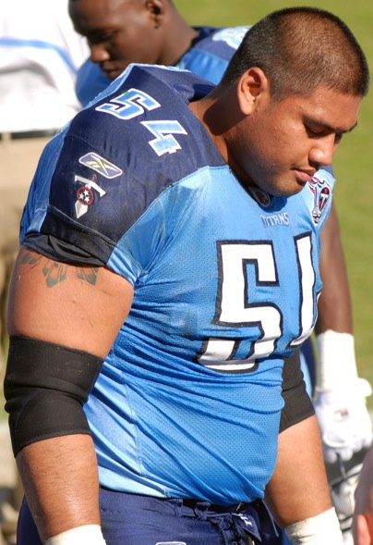

There is much fanfare when the NFL draft opens. The first-round picks of all 32 teams, baring trades, is the highlight and 15 million people view intently. In past non-COVID-19 years, top picks have feature stories befitting movie stars. The trip from seat-to-stage to meet the Commissioner has been a runway fashion show – competing for a title of most outlandish. The final round is the 7th. By that time, only parents of the hopefuls are watching.

7th rounders who sign an NFL contract with a team before training camp may have a signing bonus. That bonus is negotiable. Let’s say the bonus is $100,000, which happens. Often, the 7th rounder is cut and does not make the 53-man roster to start the season.

Some half-empty minded fans will say: “What a shame. He’s built his entire life around playing in the NFL. What is he going to do now”?

I can’t answer that, except to say, “Invest the signing bonus”.

If he were to hunker down in his parent’s basement while reconfiguring his career, and invest his entire $100,000 signing bonus, he could still be a millionaire just from that signing bonus by the time he is 65.

Of course, that is based on some assumptions, like a pre-tax return on the investment of 8%, a 3% inflation rate and a favorable tax bracket. And of course, a million dollars then will be worth less due to inflation But the point is, even with assumption-tweaking, it is entirely possible.

Take another look at the assumptions. There are still reasons for optimism. This long wait for millionaire status assumes the poor guy never makes another dime in his life. The more he makes and invests, the shorter his path to becoming a member of the M-Club.

And he may still make an NFL club. On average, a dozen or so undrafted free agents make an NFL roster. If a team thought enough of him to draft him, pay bonus money, and take the time to vet him thoroughly in camp, he must be within a range of talent that gives him a shot somewhere among similarly-minded NFL general managers and coaches.

At least, somewhere over the rainbow, a million dollars awaits those wiling to invest their signing bonus.

Roger M. Groves is a Washington DC attorney and business consultant. Formerly a tax judge, he is nationally networked with law firms and financial advisors in the sports and entertainment industry. He can be reached at (571) 228-0871, [roger@sports-apps.com](mailto:roger@sports-apps.com) or 1629 K Street N.W., Suite 300, Washington DC, 20006.