The Labor Harmony of the NFL’s New Agreement is Anything But.

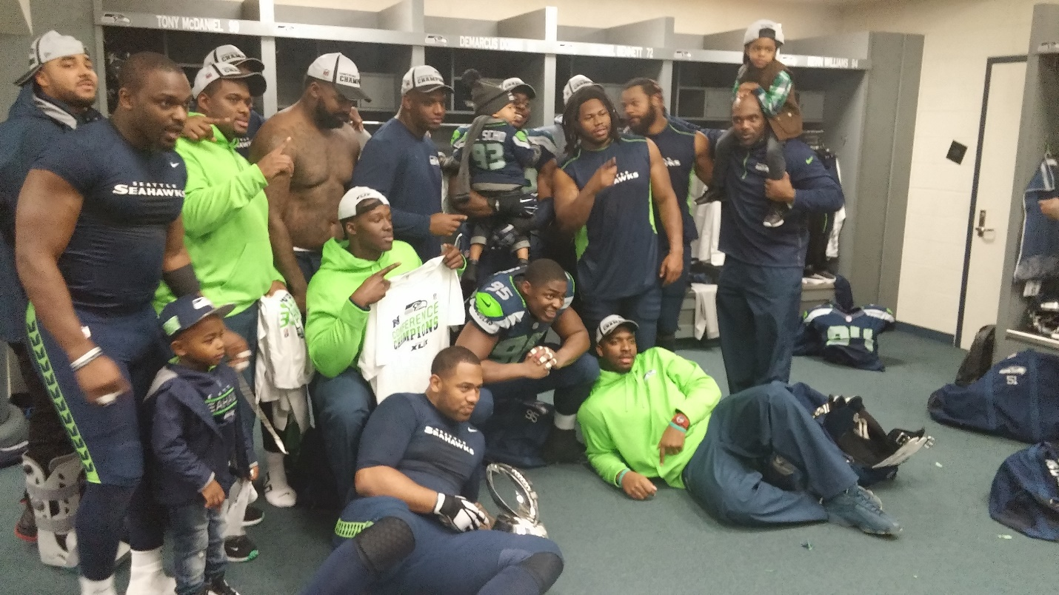

The union for NFL players just ratified the labor agreement proposed by the NFL owners. The NFL claims this new collective bargaining agreement will “reshape” the NFL and bring “labor harmony” for the next 11 seasons.[1]

Lets unpack “reshape” and “labor harmony”.

The reshaping is not fundamentally the adding of one more regular season game, or even the additional playoff game and one less preseason game. The more significant aspect is the increases in benefits to players from the bottom up. In that sense, the agreement is virtuous. It benefits the salt of the earth, the “least among us”. Minimum salaries will increase. Performance-based pay will increase. Those lowest paid players are basically looking at $100,000 more per year, from $500,000 to $600,000, a 20 percent raise.

Additionally, players close to the cut line will see 128 additional player positions available over the next two seasons (Each of the 32 teams will add 4 roster spots).

Pensions will increase.

Historians have long maintained that a society is judged by not how rich a few get, but by how the society takes care of its most vulnerable and poorest elements. The new agreement has that. Union deals that benefit the rank and file is traditionally viewed as a victory.

So what’s the problem?

The NFL claim of “labor harmony” is true to the extent that there will not be labor stoppage and the games will go on as regularly scheduled, assuming Covid 19 does not infect the schedule in perpetuity.

But within player locker rooms, there is not harmony about their relationship with owners. That is evidenced by the closeness of the vote, 1,019 to 959. The proposal only needed a simple majority for passage (50% plus 1). It got that to the tune of 51%. So almost as many voted against it.

The highest paid minority of players are least happy. They personally gain nothing from higher minimums and more marginal roster slots. When you’re getting hundreds of millions over several years, the pension is not as important as it is to the many players with 4-season careers, never making it to a second contract. So, I would not be shocked if some of the lowest paid, one-contract players may be thinking or saying, “Well, now I know where you stand, rich guy. You don’t give a damn about what’s good for me.”

Some players reportedly wanted to change their vote. The NFLPA said “No”. Some sports pundits suggest they wanted to change from “Yes” to “No.

Then there were some players that did not vote at all. None of the Yes/No players would be happy with them. This is a more fractured vote among NFL players on a CBA than has been seen in several decades.

In one sense, that dynamic among players is more a win for the NFL owners than the NFLPA. It was the NFL, not the NFLPA that proposed these benefits to the rank and file. The NFL effectively consummated a divide and conquer strategy. And the NFL owners have increased goodwill among the 1,019 players that agreed to the proposal. That fact will not be lost on the owners the next time there is a dispute during the next 11 seasons.

In other words, NFL labor peace is fragile.

Roger M. Groves in a Washington DC attorney and business consultant. Formerly a tax judge, he is nationally networked with law firms and financial advisors in the sports and entertainment industry. He can be reached at (571) 228-0871, [Roger@bizzball.org](mailto:Roger@bizzball.org) or 1629 K Street N.W., Suite 300, Washington DC, 20006.

1. Grant Gordon, <http://www.nfl.com/news/story/0ap3000001106246/article/nfl-player-vote-ratifies-new-cba-through-2030-season> March 15, 2020 (last visited March 16, 2020).