**Miami Dolphins 2020 Draft: Boom or Bust and What Everyone Else Learns from It.**

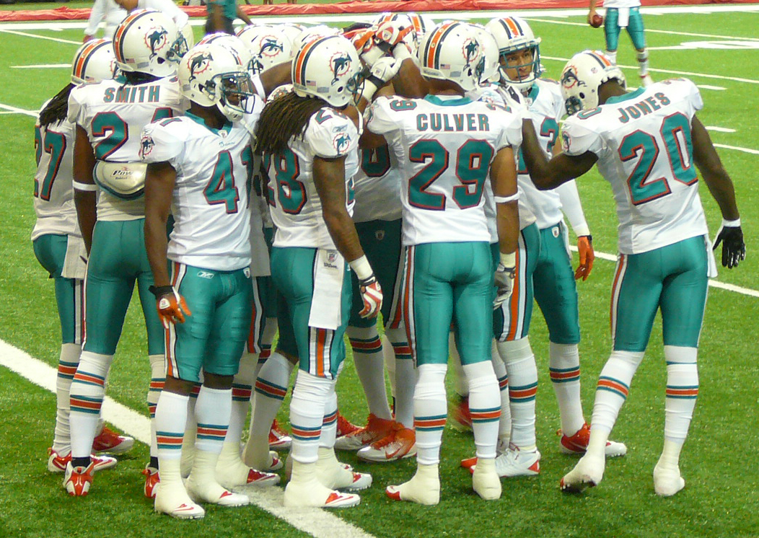

The Miami Dolphins have been planning for some time to do something special in the 2020 draft. Every cellar-dwelling team has contemplated the same thing – amass draft picks because they need help in many areas. It doesn’t usually work. The best teams in a decade don’t typically change. There is a core group of teams that consistently make the playoffs over the decades of NFL history. And then there are the Browns, Lions, Dolphins, etc. where making the playoffs is their modern-day Super Bowl.

Enter the 2020 Miami Dolphins. They were 5-11 last season, last in the AFC East. They will have 14 picks in the upcoming 2020 NFL draft, more than any other team. They have three 1st-round picks including the 5th overall, more than any other team. And according to NBC, they have the highest point total on several draft value charts (every pick has an estimated point value). No other team is close.[1]

The Dolphins did what other teams at the bottom have done, and have had to do to break the losing cycle – increase risk and shun the status quo. Since other teams also have general managers who are not Salvation Army give away specialists, the Dolphins had to give away some top talent to get draft picks. Minkah Fitzpatrick (to the Steelers) and Laremy Tunsil (to the Texans) are the only names you need to see to make that point. In return the Dolphins got the other teams’ first-round pick. Then the Dolphins added a second-round pick of the Saints.

I’m willing to bet all my virus masks that Dolphins General Manager Chris Grier has high blood pressure. Some is undoubtedly self-imposed. He told the Miami Herald: “We could build a strong team here and win for a long time…” He need not articulate the parable of horribles that could befall the Dolphins for years to come if this draft becomes a pot of fool’s gold.

But every NFL team not named Miami will do their own Dolphins Case Study. It is a copy-cap league. If Dolphins win big from this, the strategy will proliferate.

Here are some of the issues:

1. Timing: Was this the right year to stockpile draft picks? In other words, is there enough talent at the top levels to make worth mortgaging part of the future.
2. Distribution of Capital: Every team has a salary cap. Most of the aggregate salary going to a very few players, almost always involving a franchise quarterback. When you only have a few draft picks, everybody understands. But more picks mean a potential for a greater disparity between the draft money-have nots and the over-weighted wealth of a few. That does not make for easy team congruity. This comes after a contentious off-season CBA negotiation, where players at the bottom of the pay scale got an improved pay deal at the cost of another regular season game. Top paid players didn’t want another game. They would have rather sacrificed a few of their millions – millions the rank and file don’t have. Hence, some discord among teammates. This wealth inequality could hit the Dolphins harder than most other teams. An unhappy locker room could spill over onto the field.
3. Cohesiveness: Money Ball cannot measure or predict synergy, or what we call in financial valuation circles, “the value of the going concern”. A collection of new players brings new relationships. They can be good or bad. There is no slide rule that measures which personalities fit and which are unfit. The only thing certain is that uncertainty increases risk. This is where the Dolphin GM and coach will earn their salaries. I sense they have the collective instincts to meld the individual parts into a sum greater than the whole. Like in the old days, Bell Telephone wires strung together were not nearly as valuable as the functioning system – the going concern.
4. Wins: Saving the salient for the end. To slightly misquote the Bible, grace covers a multitude of sins. Grace is an unearned benefit. NFL parity rears its head every season, and reveals a thin line between wins and loses – a “lucky” break here or there. Then there are schedule breaks. Injury breaks because you avoided them. A “Missed Call” break. With or without a 14-player draft, the Dolphins could have several close games this season. Marginal wins still mean success. The opposite for losses and failure.

If the Dolphins draft strategy brings Boom times, other teams may follow, and become more aggressive in stockpiling picks. This will likely increase risk-taking among the perennial lower rung NFL teams. That also means more active off-season trading to get the picks. And that sends a message: “Highly paid unproductive players beware”. They would be shuttled off in historic numbers to make salary cap room to pay the multitude of picks.

A Dolphins Boom would also mean that the teams receiving castaway players will increase post-draft day acquisitions to shore up what they lost.

For the above reasons, every NFL GM will scrutinizing one team more they ever have before, because if the Dolphins Boom through the 2020-2021 season, the league’s entire draft day dynamics will change the following draft season.

Roger M. Groves is a Washington DC attorney and business consultant. Formerly a tax judge, he is nationally networked with law firms and financial advisors in the sports and entertainment industry. He can be reached at (571) 228-0871, [roger@sports-apps.com](mailto:roger@sports-apps.com) or 1629 K Street N.W., Suite 300, Washington DC, 20006.

1. <https://profootballtalk.nbcsports.com/2020/04/17/dolphins-have-the-most-draft-capital-by-far/> (last visited April 21, 2020. The draft value chart is here: <https://twitter.com/RNBWCV/status/1250516557236666368?s=20>