NFL PLAYERS: AVOID THE OFFSEASON WORKOUT CATASTROPHE

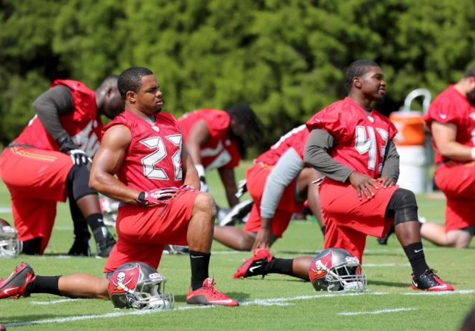

NFL players just received a nice little note from the NFL. It was a reminder and update, a goodwill gesture that can help a player’s career. No ill will. No invidious scheme. Simply: Go ahead and continue to work out on your own for the upcoming season since COVID-19 has intercepted the normal start time for “Club offseason programs”.

What the memo did not address is the issue of “what happens if you get injured during your own workouts”? The memo does admit that a player’s own workouts are technically termed “*Pre*-Phase One” offseason workouts. But the memo does not say, nor is it required to advise, that those player-inspired workouts fail to have the injury-protections of the Club’s official offseason workout program under the collective bargaining agreement. Under Article 21, Section 4 of the CBA, a player that is injured during the Club-sponsored offseason workouts has the same rights and protections he has during preseason training camp. A player injured in Pre-Phase One workouts does not.

The player should not expect an NFL memo to advise him on all the important nuances. His agent or financial advisor should fill in those gaps. Even more important, the quality agent will use such a memo to remind the player for the ump-teenth time:

“The offseason is not the time to be creative about workouts.”

The player response is reasonable on its face.

“What do you mean? I’m bored with the weight room. We do that all season, plus the routines during minicamp and mandatory training camp. This is my only time to keep in shape *my way*. And my way is to do some martial arts, wrestling and boxing.”

Now comes the propitious opportunity for the agent advisor. He or she then can say with compassionate calmness:

“Your creativity is commendable. But you signed an addendum to the standard NFL Player Contract prohibiting you from engaging in ‘Hazardous Activity’. Guess what activities are included in that definition? Answer: Each of your creative workouts. Each can cause you a significant financial loss.”

So, while this COVID-19-induced delay creates additional opportunity to vary the proscribed workout routines, the better advice is to temper your well-intentioned creative offseason workout plans with cranial knowledge of CBA Article 21, and any club addendum to the standard player contract.

Roger M. Groves in a Washington DC attorney and business consultant. Formerly a tax judge, he is nationally networked with law firms and financial advisors in the sports and entertainment industry. He can be reached at (571) 228-0871, [Roger@bizzball.org](mailto:Roger@bizzball.org) or 1629 K Street N.W., Suite 300, Washington DC, 20006.