With the Benefit of Hindsight, which of the 20 Highest Paid Coaches was Least Deserving?

Hindsight can be a wonderful learning tool. We can look back with the benefit of time to see decisions made when, as most executive decision-makers will tell you, “We had to make a quick decision on imperfect information”.

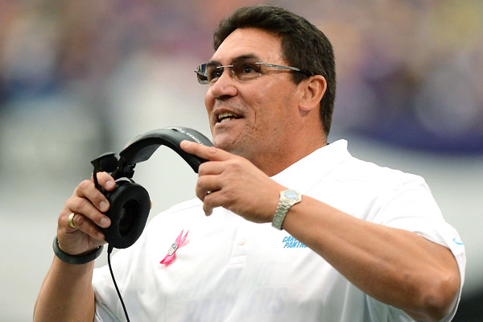

Here is a list of the 20 highest paid coaches in America in 2019, regardless of sport.[1] Since they all have multi-year contracts, the calculation is of the average contract value. My question is simply: Which one was the biggest mistake or least deserving?

|  |  |  |  |  |
| --- | --- | --- | --- | --- |
| RANK | COACH | TEAM | AVERAGE CONTRACT VALUE | CAREER WINNING % |
| 20 | Jim Harbaugh | Michigan Wolverines | $7.73 million | .667 |
| 19 | Ron Rivera | Carolina Panthers | $7.75 million | .546 |
| 15 (tie) | Andy Reid | Kansas City Chiefs | $8 million | .613 |
| 15 (tie) | Rick Carlisle | Dallas Mavericks | $8 million | .547 |
| 15 (tie) | Mike Tomlin | Pittsburgh Steelers | $8 million | .650 |
| 15 (tie) | Dan Quinn | Atlanta Falcons | $8 million | .513 |
| 13 (tie) | Erik Spoelstra | Miami Heat | $8.5 million | .594 |
| 13 (tie) | Sean McVay | Los Angeles Rams | $8.5 million | .705 |
| 12 | John Calipari | Kentucky Wildcats | $8.6 million | .781 |
| 10 (tie) | Mike Krzyzewski | Duke Blue Devils | $9 million | .768 |
| 10 (tie) | John Harbaugh | Baltimore Ravens | $9 million | .606 |
| 9 | Dabo Swinney | Clemson Tigers | $9.3 million | .810 |
| 8 | Nick Saban | Alabama Crimson Tide | $9.4 million | .791 |
| 7 | Steve Kerr | Golden State Warriors | $9.5 million | .755 |
| 6 | Sean Payton | New Orleans Saints | $9.75 million | .627 |
| 4 (tie) | Jon Gruden | Oakland Raiders | $10 million | .515 |
| 4 (tie) | Doc Rivers | Los Angeles Clippers | $10 million | .578 |
| 2 (tie) | Pete Carroll | Seattle Seahawks | $11 million | .602 |
| 2 (tie) | Gregg Popovich | San Antonio Spurs | $11 million | .680 |
| 1 | Bill Belichick | New England Patriots | $12 million | .684 |

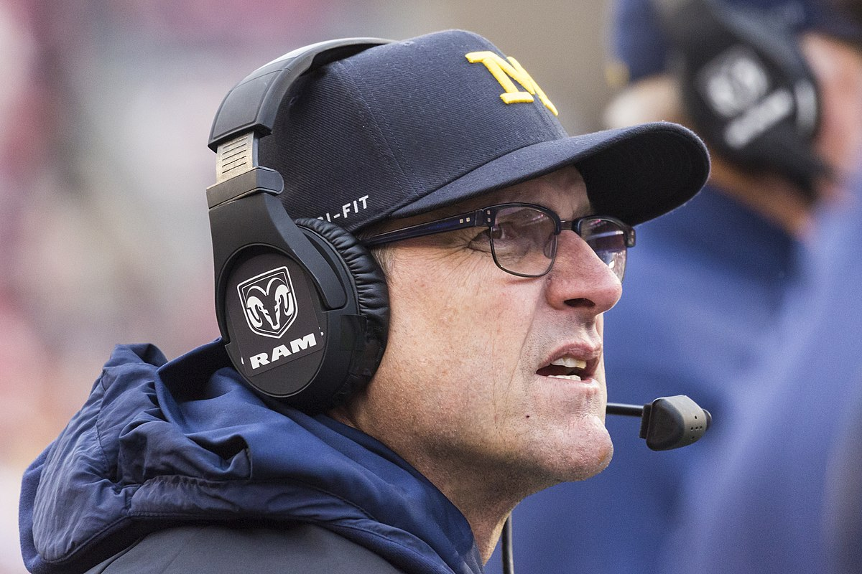

With the media and fan fascination with titles, we know who will not be candidates for least deserving. Bill Belichick and Nick Saban have both won six of their sport’s most coveted championships. Gregg Popovich and Mike Krzyzewski have both won five.

By that measure, Jim Harbaugh is on the hot seat. It is not just that he has not won a National Championship at Michigan, and not been to the collegiate level playoffs. He lost to the hated measuring stick Ohio State Buckeyes each of the five times he has played them. When you are 0-5, you have some “splainin” to do.

Of the remaining coaches without a title, two coaches have a seat at the table, in my opinion. Ron Rivera is one. He has won just over half of his games (.54). Some would rather blame defrocked quarterback Cam Newton for that. But you know where the buck is supposed to stop. The other is Atlanta Falcon’s Dan Quinn. Getting to the Super Bowl is more of a top-end achievement than what Harbaugh or Rivera have accomplished. But winning only one third of his games since his contract extension in July 2018 leaves him uncomfortably close to the other two coaches.

In the end, a major factor is what the decision-makers were paying for, and I think the desire to consistently beat Ohio State was a more compelling cause to pay Harbaugh big money than the Panthers or Falcons had for paying their coaches. If along the way, there was a Big 10 Championship or a Final Four appearance in the College Playoffs, the financial pill would not be as hard to swallow. One can argue: “Yea, well, that’s why he’s 20th on the list”. But there are only two other college football coaches paid more than Harbaugh. Their names are Saban and Sweeney. The difference in the important metrics between those two and Harbaugh is a gulf that is deep and wide. The good news for Wolverine fans is that Harbaugh recruits enough high-quality talent to be in the conversation about top programs. But the third highest salary in his sport is not paid for a conversation. So, for these reasons Michigan has experienced the biggest disappointment from contract signing to the present, despite an overall impressive record. Harbaugh gets the trophy nobody wants.

1. Kurt Badenhausen, *The 20 Highest-Paid Coaches in American Sports 2019*, December 5, 2019.