The NCAA Moves Forward on Permitting Players to Profit

from Their Own Name, Image and Likeness

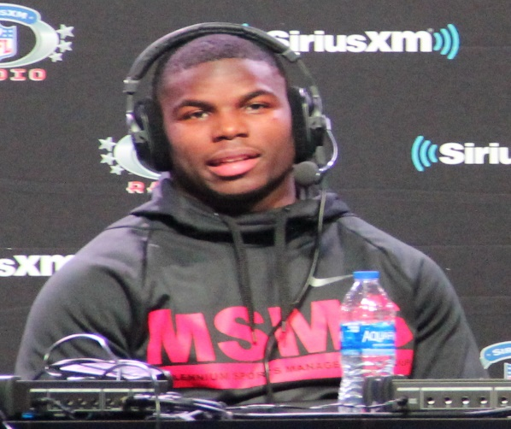

In October 2019, the NCAA Board of Governors announced a policy allowing student athletes to “benefit from the use of their name, image and likeness…” The policy was not a NCAA bylaw or rule to be enforced. And it was not necessarily a wholesale endorsement of players being paid under all circumstances. That much was clear because the next phrase in the policy statement was that the player benefit must be “in a manner consistent with the *collegiate model*”.

That obviously begs the question: “What is the collegiate model”?

There has not been a collegiate model for player profitability previously, because NCAA rules prohibited scholarship athletes from profiting from their own name, image, and likeness (“NIL”). The only model was amateurism – if you get paid you lose your amateur status, lose your grant in aid scholarship and lose your eligibility to play in NCAA activities.

This week, the NCAA shed some light on the new NIL model. The Board of Governors directed schools at *all* divisions to consider rule changes consistent with the recommendations made by an internal working group. Below are the significant player profit-making activities permitted under the recommendations. They are called personal business actions, where a player’s NIL is used and they profit from:

* Their own camps, clinics, or lessons (group or individual I assume).
* Developing and distributing social media content
* Promoting their own athletic or non-athletic business
* Autographs
* Creating and modeling athletic and non-athletic clothing apparel.
* Promoting commercial products and services, as long as they do not use their school’s uniforms, apparel or intellectual property (e.g. trademarks) or apparel.
* Personal appearances, even at commercial locations, as long as they do not use their school’s uniforms, apparel or intellectual property.

So, for example, a player that becomes an influencer with say 200,000 followers on the player’s Instagram account, and receives advertising revenue every time the player promotes a Nike shoe, that player would be able to keep the money and his or her eligibility.

Of course, any bylaw changes will have devilish details. Anticipate some restrictions on the school’s ability to participate in, jointly profit from, or dictate the circumstances for the player’s own profitmaking activities. As seen in the above directives, the Board of Governors will be attempting to draw clear boundaries between school activities and a player’s own NIL activities for his or her own profit.

Also anticipate detailed disclosure requirements on the players. This would likely include revealing the contracts the player has with the companies or individuals involved in generating the NIL revenue.

And anticipate that players will be allowed to have representatives to assist them with those contracts and disclosure requirements. It will be interesting to see how the NCAA will define those representatives. Will they include the same people who are agents for the player’s professional future? I suspect that whatever definition is created, the representative cannot simultaneously be working to establish his or her professional career in sports.

We should all look forward to further announcements this June, when the NCAA meets with Division 1 conferences. There is reason to be optimistic that real change will happen within the NCAA before the 2021-2022 season. The NCAA is well aware of states that have passed their own player NIL laws (California and Colorado) and several other states on the precipice of doing the same (Florida, New York, New Jersey, and Virginia). Those states all envision implementation soon, with Florida likely to have Governor DeSantis sign the finalized law with an effective date of July 1, 2021.

Future posts will address some of the possible outcomes and consequences. I can tell you now I am confident the sky is not falling, and the fall out will not cause any school to close from lack of self-sustaining revenue.

Roger M. Groves is a Washington DC attorney and business consultant. Formerly a tax judge, he is nationally networked with law firms and financial advisors in the sports and entertainment industry. He can be reached at (571) 228-0871, [roger@sports-apps.com](mailto:roger@sports-apps.com) or 1629 K Street N.W., Suite 300, Washington DC, 20006.