**New Concussion Era Favors NFL Owners with Career Strategy Consequences for Players.**

Earlier this year, the NFL announced that the number of *preseason* concussions among NFL players rose in 2019 from the prior year (from 214 to 224). They also announced that both years are well below the prior 3-year average from 2015 through 2017 of 266 concussed players.[1]

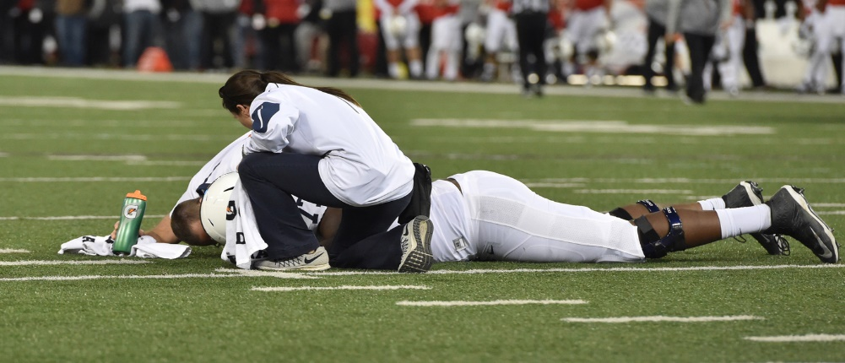

But that is not the real story.

You may remember the class action lawsuit by retired NFL players against the NFL, and the settlement that will likely have a payout north of $1 billion. The settlement was August, 2013.

That was then. This is now.

Now, NFL’s current players are not part of the settlement. They have no payouts waiting for them after their concussions. Nor do those who recently retired after the cut-off date from the settlement.

Now, those current and recently retired players are less appealing to law firms that can skillfully bring a class action suit. There are hundreds of concussed players. None with uncontroverted amounts of CTE in their brain. That is not same 4.500 plaintiffs that included the estates of severely debilitated or deceased former players. Law firms carefully consider whether to bring class action suits. They know they must fund the litigation for years, and get paid on a contingency basis. They must ask questions like, “Are we sure we will win, and if we do, will the firm make enough money in the end to pay for the years of non-payment from other clients”.

Now, the NFL does not have to pay for failing to tell players what they *really* knew about the connection between football and CTE and when they knew it. The public knows the settlement was for that purpose, and will eventually reach $1 billion in payouts.

Now, the NFL does not face the same public pressure to make the game safer. The NFL can note a reduction in concussions in 2018 and 2019 from the prior three years. Now there are protocols to perform concussion assessments during games and practices. They can boast of several other preventive measures like reduced practices in pads, helmet improvements in design, and the enhanced penalties designed to change the way the game is played for player safety.

The point is that concussed players today have a far less favorable environment for claiming damages for decades of unredressed sins than at the time when the 2013 movie Concussion was amassing its $249 million in box office receipts. Gone is the cover up. Gone is presumptive legal case for negligence in failing to adequately inform and treat players.

Now what?

Players will continue to get concussions. Yet, if the NFL does not provide adequate compensation for their loss, they will have less access to the best class action law firms, due to the economics discussed above.

So, what should current concussed players do?

Remember, NFL players have a career of 4.5 years, on average. So, consider this starter list, knowing you cannot rely on a portion of that billion-dollar settlement:

* Save and invest your salary wisely in case you are concussed and thereafter unable to work.
* Accelerate a secondary game plan for a career after football for the same reason, but do it *while* you are still playing.
* Monetize your popularity while you are still “popular”. Endorsement deals do not have to be Nike or bust. They do not even have to be apparel deals. The deal can be whatever you use or create – a certain diet, exercise regimen, lyrics, beats, art like Kanye West, or math games that use sports.
* You should obviously take the tackling techniques seriously if you play defense. Take to heart the NFL’s commercial “Way to Play – Building a Better Game”, featuring Khalil Mack. <https://www.ispot.tv/ad/o8Qz/nfl-building-a-better-game-featuring-khalil-mack>. It has already aired over 400 times to increase goodwill with the fans.
* You may rethink how long you play the game, especially if you receive medical advice that you are a high risk for permanent CTE damage.

Of course, we are talking about people who play for the love of the game – and are willing to sacrifice much for it. Love and business decisions do not always sleep together. That poses a choice and choices have consequences. Chose wisely.

Roger M. Groves is a Washington DC attorney and business consultant. Formerly a tax judge, he is nationally networked with law firms and financial advisors in the sports and entertainment industry. He can be reached at (571) 228-0871, [roger@sports-apps.com](mailto:roger@sports-apps.com) or 1629 K Street N.W., Suite 300, Washington DC, 20006.

1. See <https://www.espn.com/nfl/story/_/id/28547607/nfl-number-reported-concussions-rose-slightly-2019-previous-season>